

**Department of**

**Computer Science and Engineering**

**Lab Report - 03**

Course No.              : CSE-308

Course Title             : System Analysis and Design Laboratory

Submitted By         :

  Name : 1 . Tasmim Sultana(129)

  2 . Fatama Jannat Tisha (131)

                                   3 .  Kamelia Zaman Moon (299)

                               4  .Umma Salma (302)

                                   5 . Sabrina Afrin Toma (304)

         Session        : 2017-18

         Semester     : 3rd year 1st Semester

Date            : 19-07-2020

Submitted To:

Md Musfique Anwar

         Associate Professor, Department of Computer Science and Engineering

         Dr. Md Humayun Kabir

Professor, Department of Computer Science and Engineering

Jahangirnagar University, Savar

**Experiment No. 03**

**Title**

User Story of Online Class and Examination System

**Objective**

A user story is an informal, natural language description of one or more features of a software system .A user story describes the type of user, what they want and why .A user story helps to create a simplified description of a requirement.

**Procedure**

A user story is defined incrementally, in three stages:

· Card - The brief description incrementally of the need

· Conversation - The conversations that happen during backlog grooming and iteration planning to solidify the details

· Confirmation - The tests that confirm the story’s satisfaction completion .Confirmation divided into two parts, are success.

Card

Card represents 2-3 sentences used to describe the intent of the story that can be considered as an invitation to conversation. The card serves as a memorable token, which summarize intent and represents a more detailed requirement, whose details remain to be determined.

Card can be written the way given below

As a (role) of the product, I can (do action) so that I can obtain (some benefits/value)

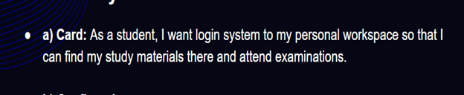

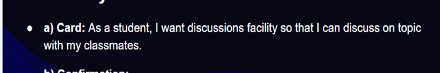

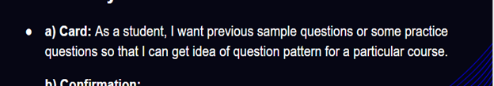

Conversation

Conversation represents a discussion between the target users, team , product owner , and other stakeholders ,which is necessary to determine the more detailed behaviour required to implement the intent .

Confirmation

Confirmation represents the Acceptance Test , which is how the customer or product owner will confirm that the story has been implemented to their satisfaction .In other words , confirmation represents the condition of satisfaction that will be applied to determine whether or not the story fulfils the intent as well as the more detailed requirements.

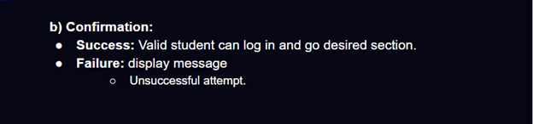

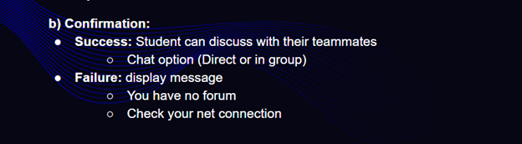

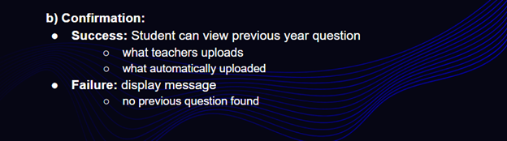

**Discussion**

With a user story approach , we replace big upfront design with a just enough approach .User stories reduce the time spent on writing exhausting documentation by emphasizing customer-centric conversation .Consequently ,user stories allow teams to deliver quality software more quickly ,which is what customers prefer.